PRESS RELEASE
STARHAUS, Pioneering the Future of Sustainable and Human-Centric Manufacturing
Kick-off Meeting
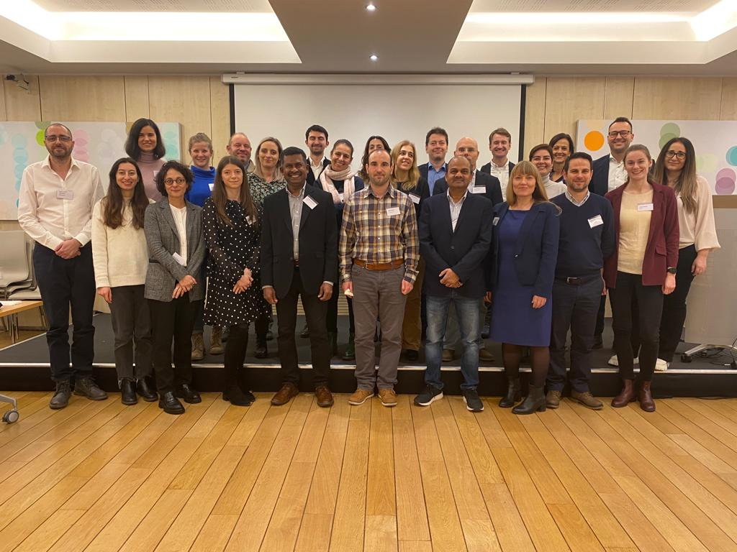

Date: 13.12.2023
Location: Brussels, Belgium, Norway House
We are delighted to announce the commencement of STARHAUS, the project designed to revolutionize the manufacturing industry by introducing innovative synergies between customized production and consumption models. This initiative aligns perfectly with the European vision of a greener, more inclusive, and smarter future.
Supported by the European Union’s Research and Innovation program, Horizon Europe, STARHAUS is a groundbreaking project that embodies the essence of the New European Bauhaus. It is a step forward in sustainable, technological, accessible, and resilient (STAR) manufacturing, focusing on human-centric approaches, consisting in 6 working packages and covering a range of technological advancements. The Kick-off Meeting took place in Brussels, on December the 13^{th,} 2023, with the participation of the members of the consortium, along with the Project Officer. After a welcome message addressed by the Project Officer and an overview by coordinator SINTEF, each work package leader presented their plan and mapped out the next steps. The KoM continued with two workshops, (I) Technology Foundation - Hardware and Software - organized by WIZ and CODY and (II) Science, Technology & the ARTS collaboration - organized by INOVA and DBL.

Key Highlights of STARHAUS:
Sustainable Solutions: Prioritizing eco-friendly materials and processes, STARHAUS aims to significantly reduce the environmental footprint of manufacturing activities.
Technological Advancements: Leveraging cutting-edge technologies to enhance efficiency, precision, and customization in production processes.
Accessible Design: Ensuring that our products and services are inclusive, catering to a wide range of needs and preferences, thereby democratizing quality manufacturing.
Resilient Frameworks: Building robust systems capable of withstanding various economic and environmental challenges, ensuring long-term sustainability.
General Objective: Facilitate widespread community adoption of sustainable customized fast moving consumer goods through a human-centered approach for a decentralized, localized and urban manufacturing.
Specific Objectives: 1. Support a decentralized manufacturing vision and engage communities into sustainable production and consumption. #factory, #community; 2. Promote collaborative models between domain experts, social scientists, artists, and technology providers to support the development of innovative products, processes and services. #collaboration; 3. Stimulate the regeneration of manufacturing spaces based on the NEB innovation approach. #factory, #collaboration, 4. Enable the growth of efficient, effective, sustainable, symbiotic and stakeholder-aligned manufacturing methods through re-use, adapt, re-design and repurpose of existing technologies (TRL5) #technology, #innovation; 5. Measure the impact of behavioral change towards sustainability through participatory models including consumers, researchers, technology providers and public authorities. #impact, #collaboration, #social; 6. Design, test and validate novel concepts of human-centered customized products produced with a focus on sustainability and circularity. #human-centered, #validation, #impact, #sustainability

STARHAUS is more than a project; it's a movement towards rethinking how we produce and consume. It's about creating a balance between functionality, aesthetics, and sustainability. This initiative is a step towards realizing the European Union’s vision for a resilient and sustainable economy.
The project is grounded on a strong partnership, including leading industry experts, academic institutions and municipalities committed to bring this vision to life, to shape a future that respects our planet and its inhabitants.
Join the journey of STARHAUS. Stay tuned for more updates and milestones as it progresses in this exciting venture.
For further information, media inquiries or interviews, please contact:
Raluca Antonie, Communication Manager
Phone: 0040-749-060690
Email: raluca.antonie@fspac.ro

About the New European Bauhaus: An interdisciplinary initiative of the European Union, the New European Bauhaus blends aesthetics with technology, sustainability and inclusivity, aiming to create a better future.

